30. POSITIVE OR NEGATIVE NUMBER

CODE:

%{

int positive_no = 0, negative_no = 0;

%}

%%

^[-][0-9]+ {negative_no++;

printf("negative number = %s\n",

yytext);} // negative number

[0-9]+ {positive_no++;

printf("positive number = %s\n",

yytext);} // positive number

%%

int yywrap(){}

int main()

{

yylex();

printf ("number of positive numbers = %d,"

"number of negative numbers = %d\n",

positive_no, negative_no);

return 0;

}

OUTPUT:

C:\Users\prith>cd desktop

C:\Users\prith\Desktop>cd flex

C:\Users\prith\Desktop\FLEX>flex positive_or_not.l

flex: can't open positive_or_not.l

C:\Users\prith\Desktop\FLEX>flex positiveornegative.l

C:\Users\prith\Desktop\FLEX>gcc.lex.yy.c

'gcc.lex.yy.c' is not recognized as an internal or external command,

operable program or batch file.

C:\Users\prith\Desktop\FLEX>gcc lex.yy.c

C:\Users\prith\Desktop\FLEX>a.exe

-10

negative number = -10

20

positive number = 20

^Z

number of positive numbers = 1,number of negative numbers = 1

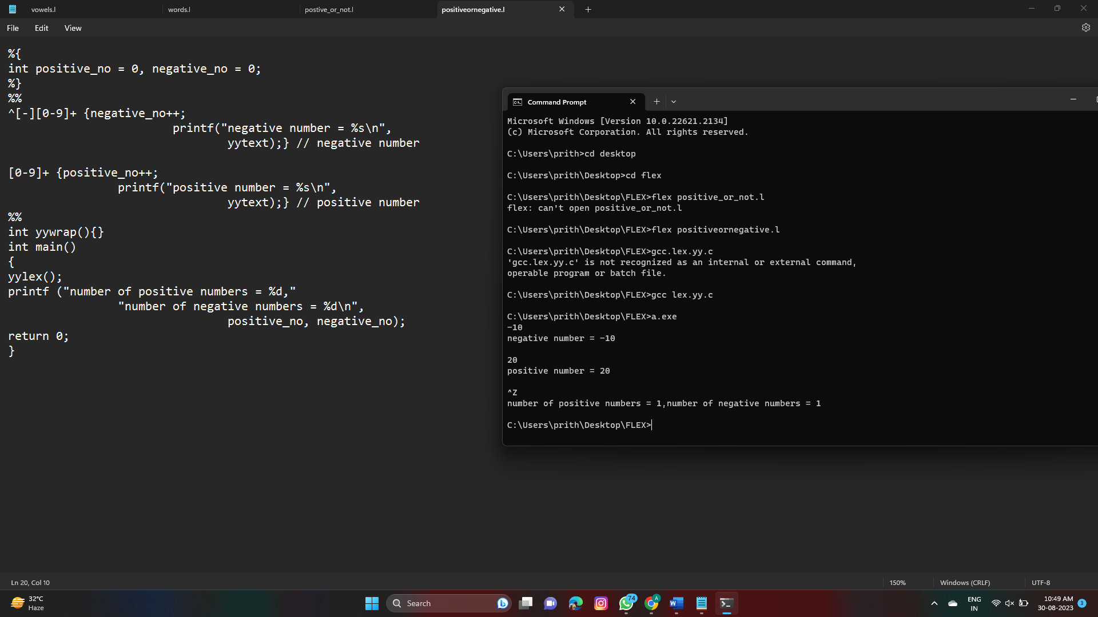S